Copyright for test papers and marking guides remains with West Australian Test Papers.
Test papers may only be reproduced within the purchasing school according to the advertised Conditions of Sale.
Test papers should be withdrawn after use and stored securely in the school until Friday, 1 December 2017.



SEMESTER TWO

MATHEMATICS
METHODS
UNITS 1 and 2

2017

SOLUTIONS

Calculator−free Solutions

1. Origin is at (2, 8)
Radius = 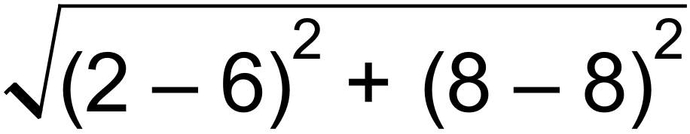
= 4
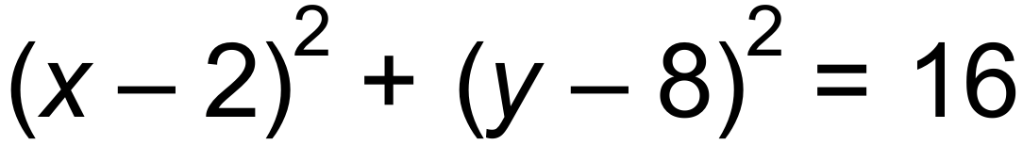 [2]

2. (a) 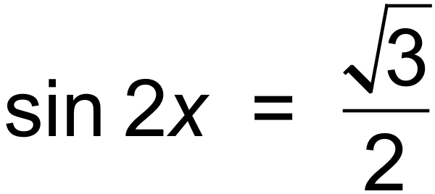
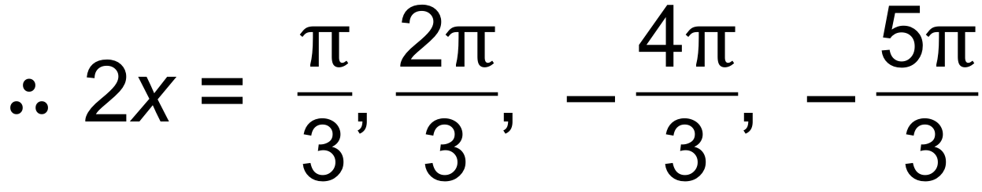
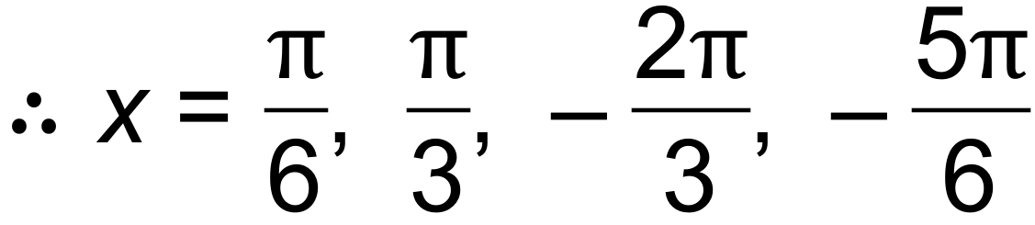
(b) cos x cannot be more than 1. [4]

3. (a) 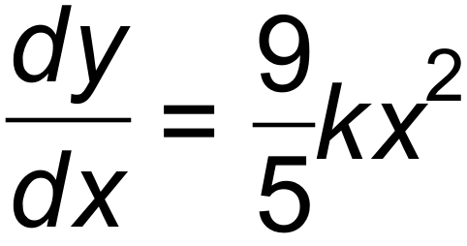
(b) 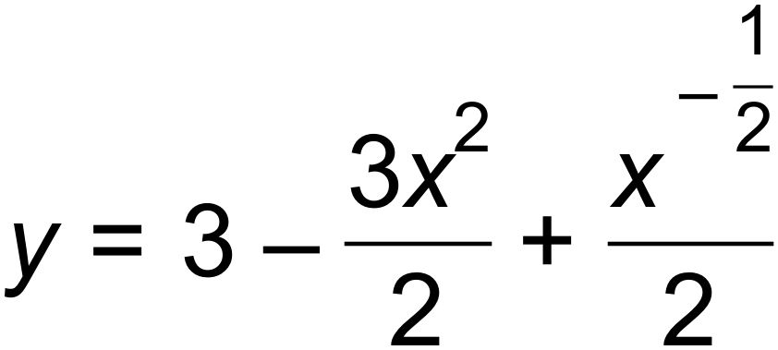
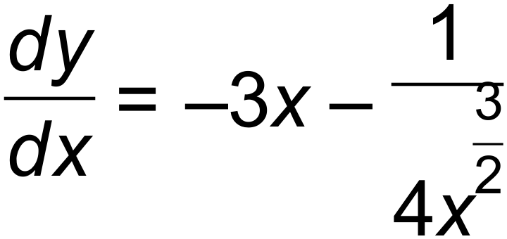
(c) 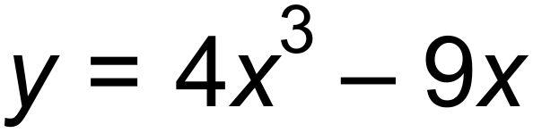
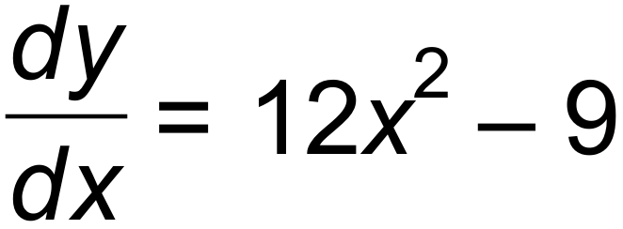 [7]

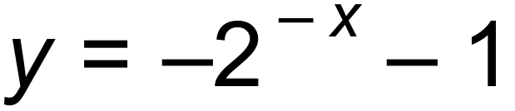 | 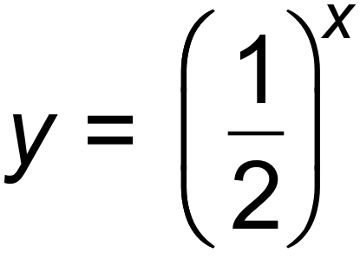 | 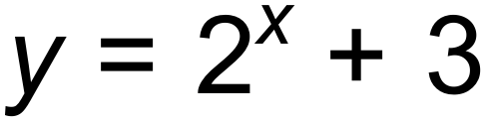 | 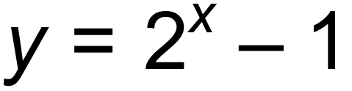
D | A | B | C
4.

[4]

5. (a) (i) 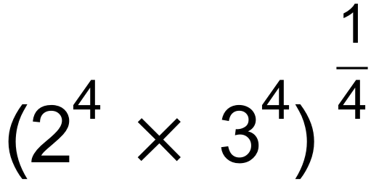
= 6
(ii) 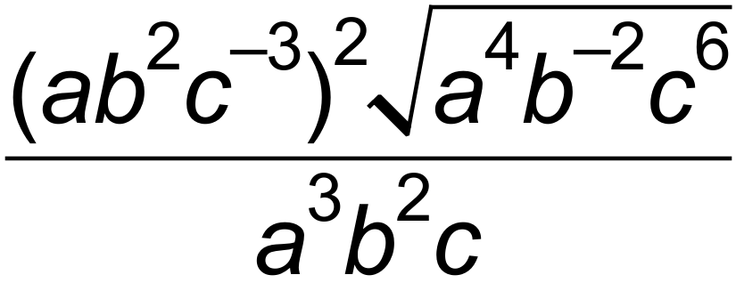
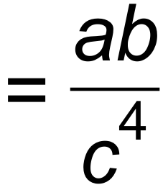
(iii) 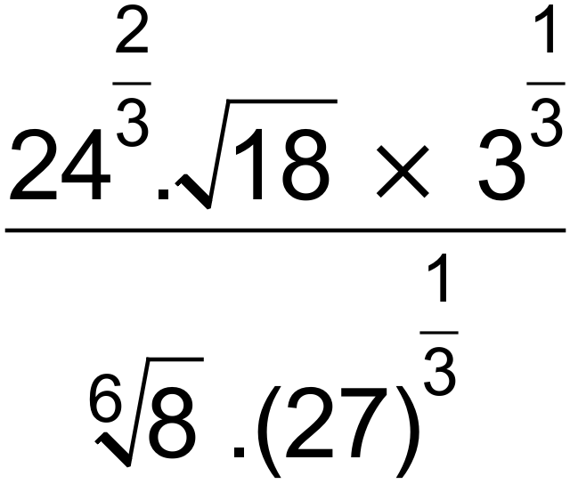
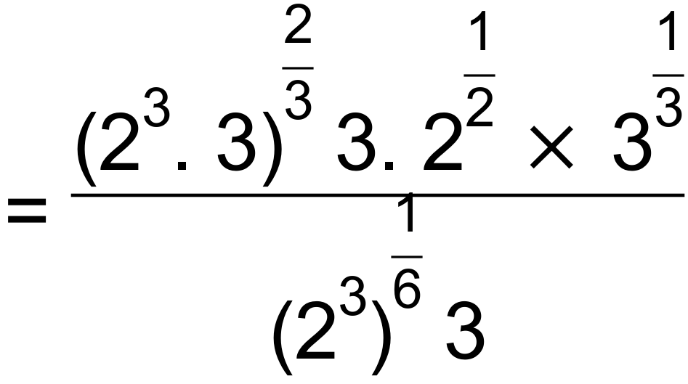
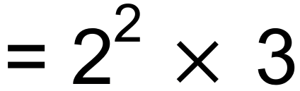
= 12

(b) (i) 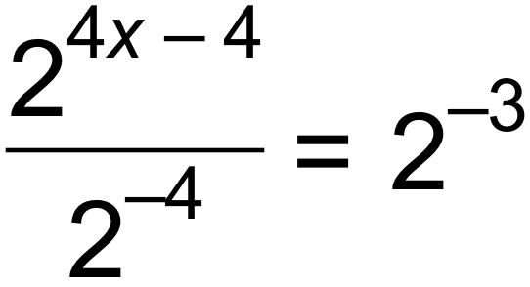
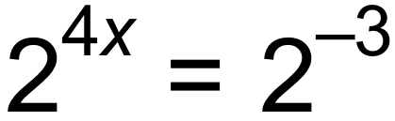
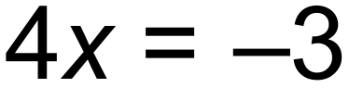
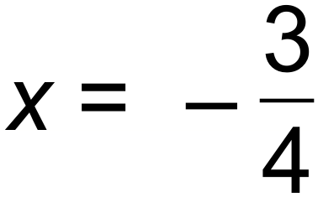
(ii) 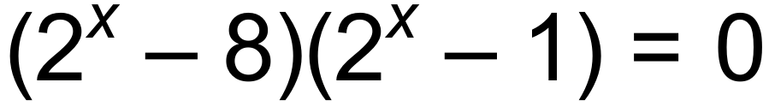
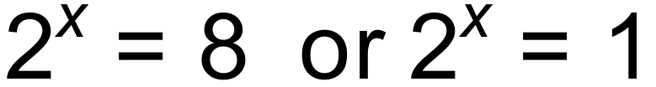
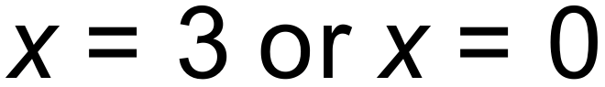 [11]

6. (a) (i) 0.2
(ii) 0.4
(iii) 0.7
(b) 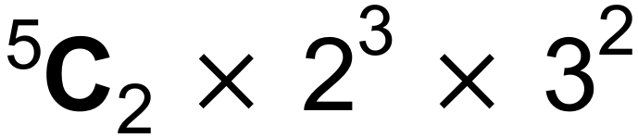 = 720 [5]

7. (a) (i) 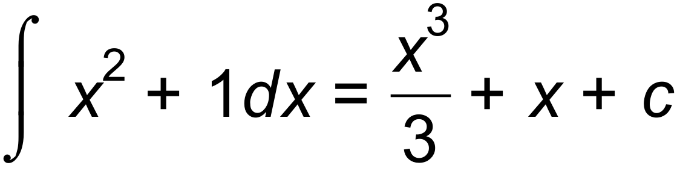
(ii) 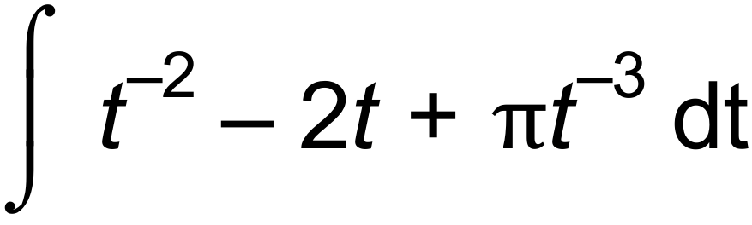
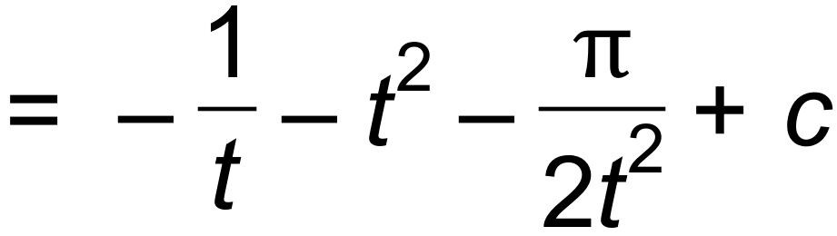
(b) 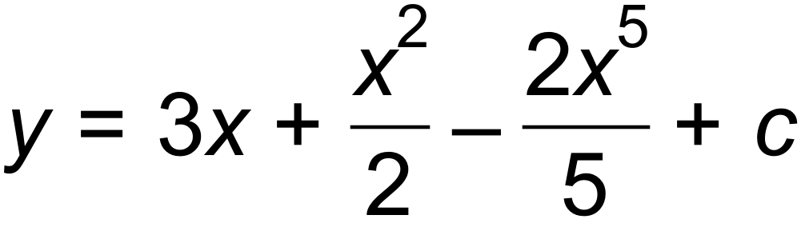
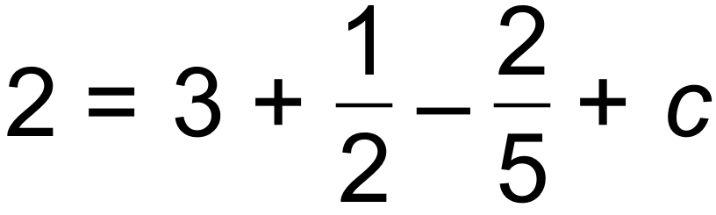
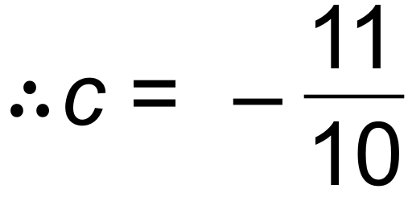
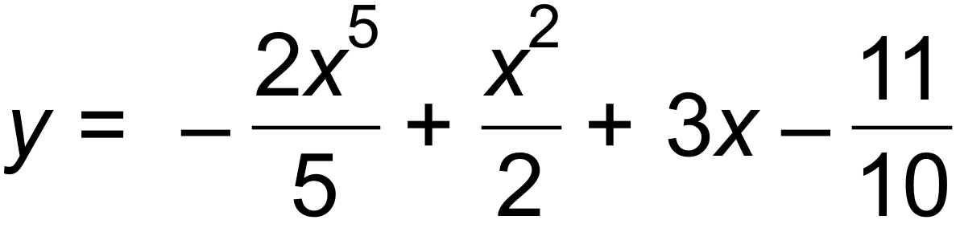 [8]

8. (a) 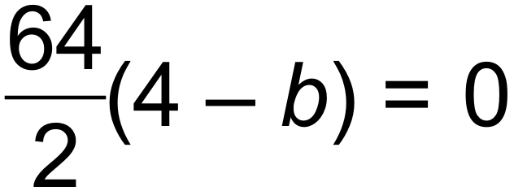
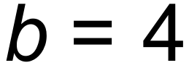
(b) 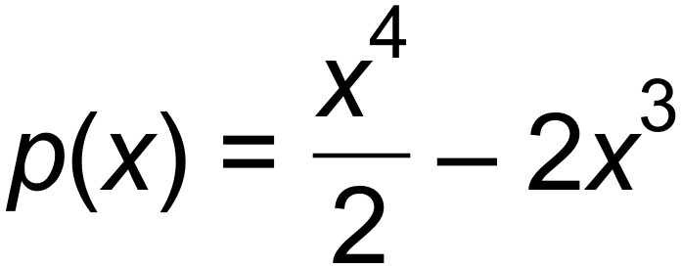
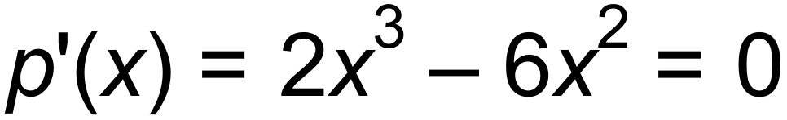
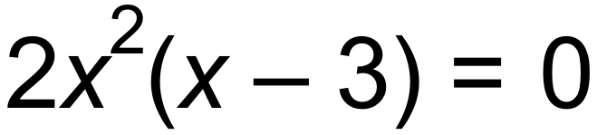
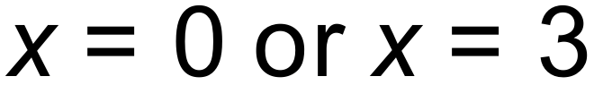 (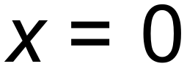 is not a minimum)
When 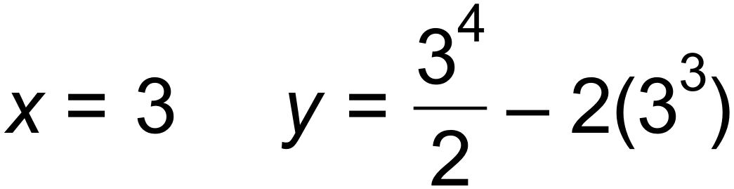
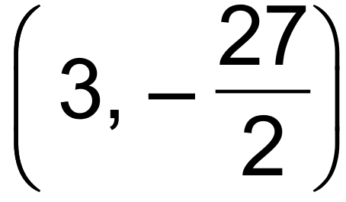
(c) Stationary point at 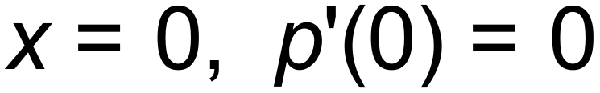
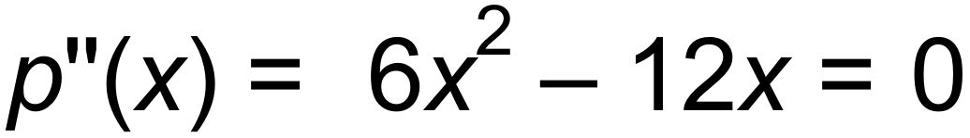
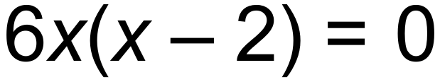
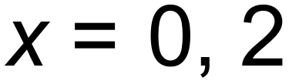
[6]
Horizontal point of inflection
Or sign table:
 | 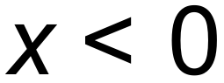 |  | 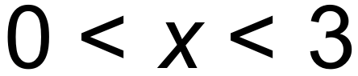 | 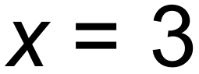 | 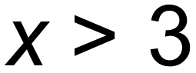
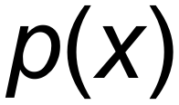 | $$↓$$ | $$↔$$ | $$↓$$ | $$↔$$ | $$↑$$
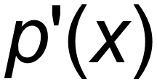 | - | 0 | - | 0 | +

9. (a) a₁ = 3
a₂ = 6
a₃ = 10
(b) T_{n+2} = T_{n} + T_{n+1} T₁ =1 T₂ = 1 [3]

Calculator−assumed Solutions

10. (a) 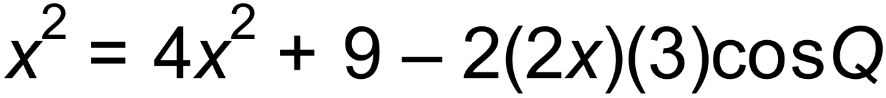
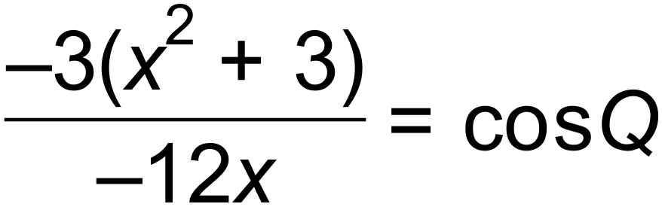
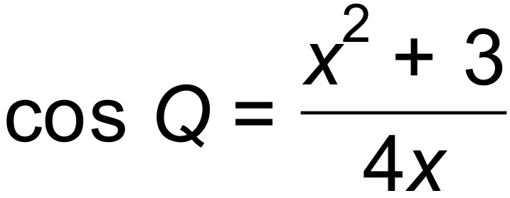
(b) cos Q = 0.9125
Q = 24.1468°
Area = 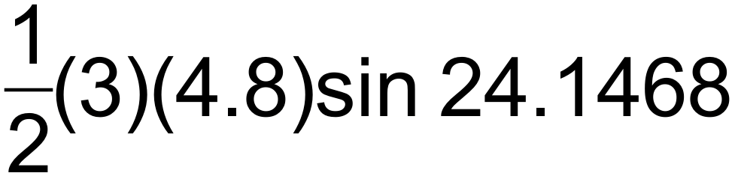
= 2.945 units² [5]

11. (a) 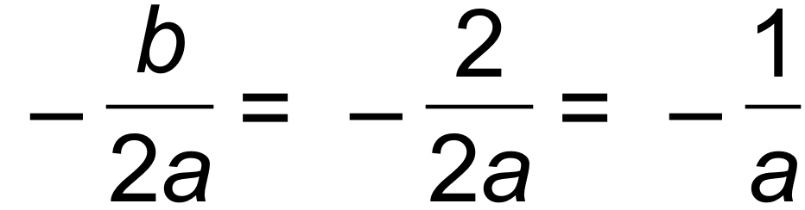
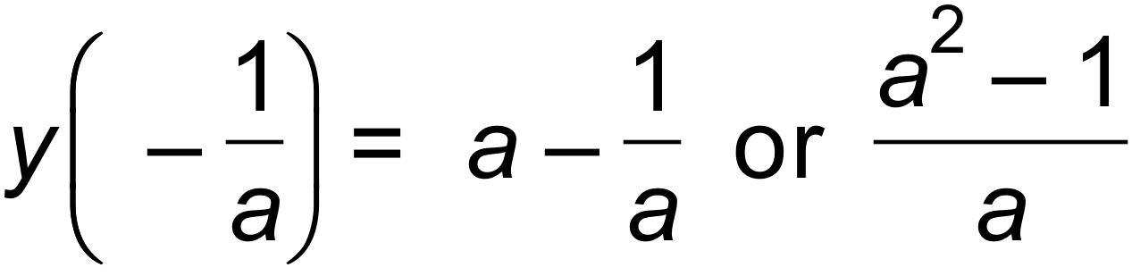
Turning point 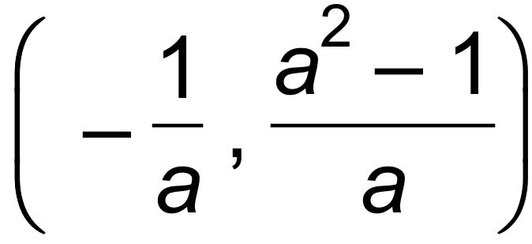

(b) 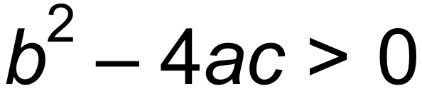
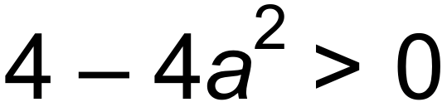
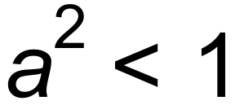
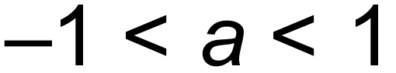 [4]

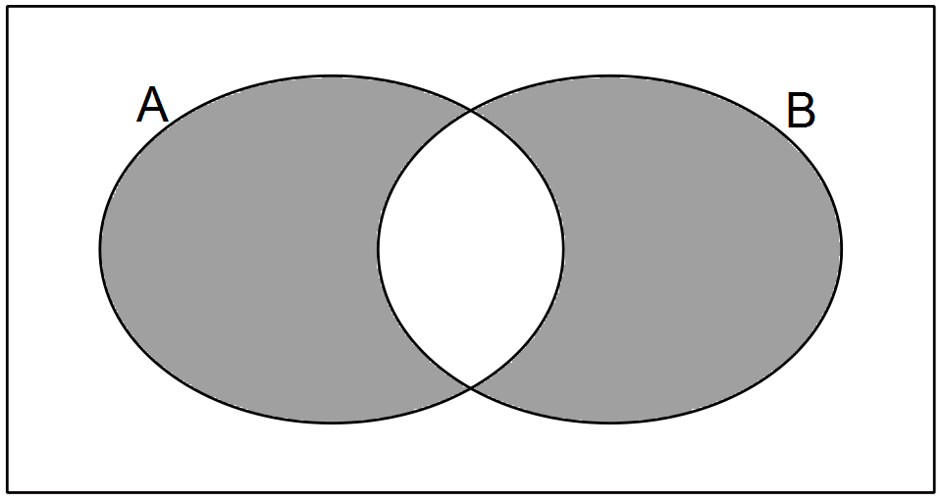12. (a)

(b) (i) 0.1
(ii) 0.2
(iii) 0.3
(iv) 0.9 [5]

13. (a) 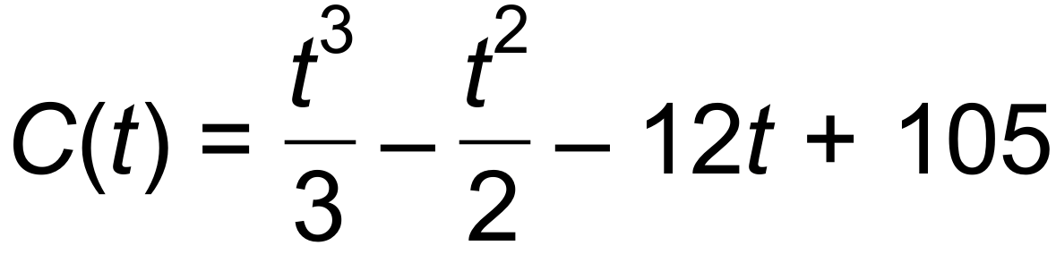
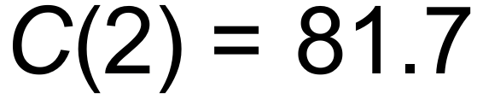 cents
(b) 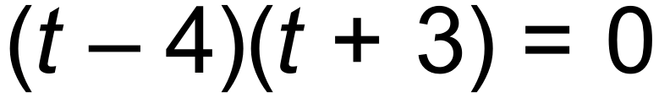
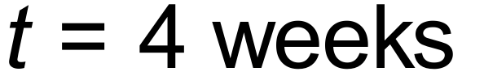
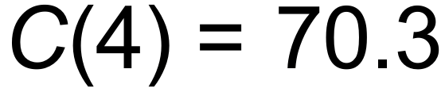 cents
(c) Week 6.8 therefore during week 7 [5]

14. (a) 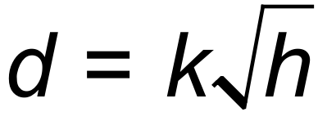
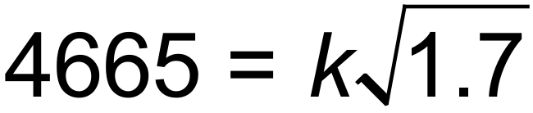
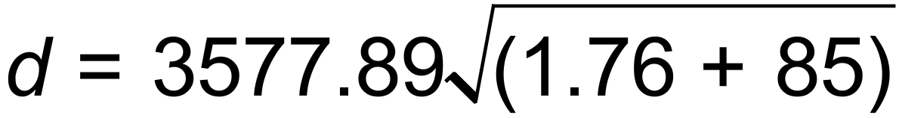
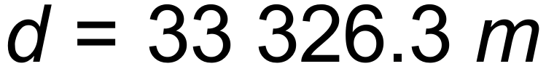
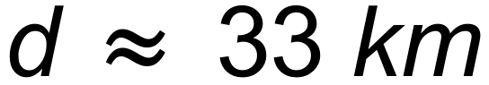
(b) 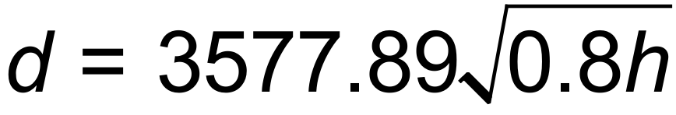
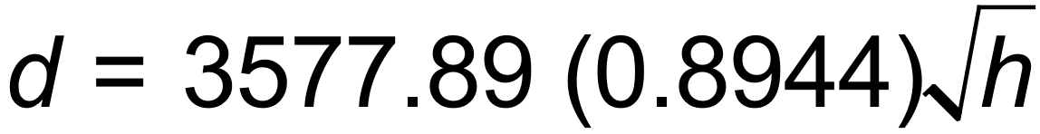
d decreases by 10.6%. [5]

15. (a) (i) T_{n+1} = T_{n} + 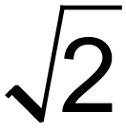 T₁ = 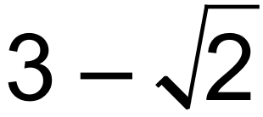
(ii) T_{n+1} = 3 T_{n} T₁ = 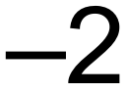
(b) T_{n} = 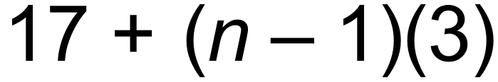
T₂₅ = 17 + (24)(3)
= 89 [6]

16. (a)
h → 0 | Limit =
0.1 | 3.05
0.01 | 3.005
0.0001 | 3.00005
0.000001 | 3.0000005

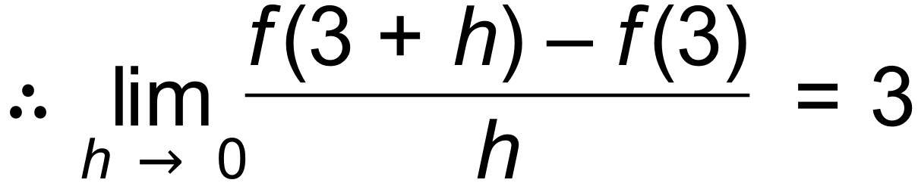
(b) 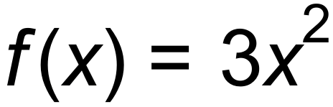
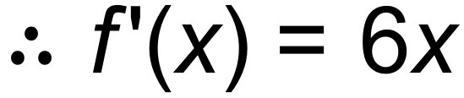
(c) 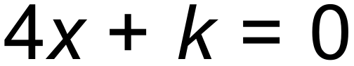
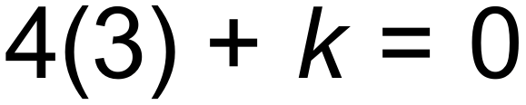
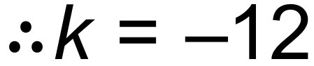
(d) 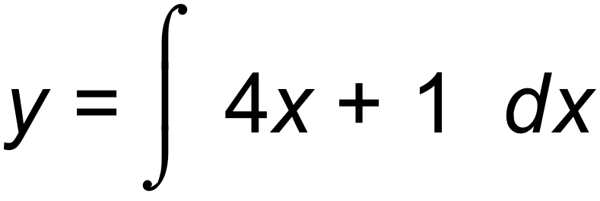
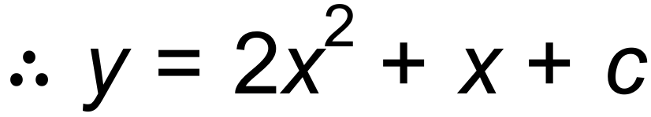
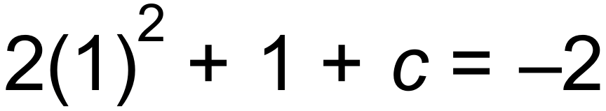
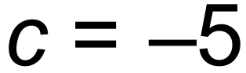
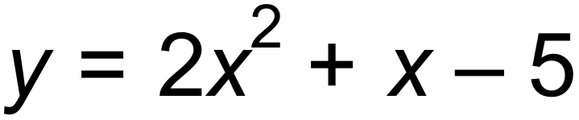 [9]

17. (a) 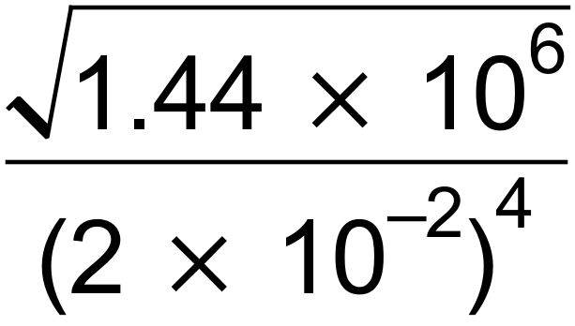
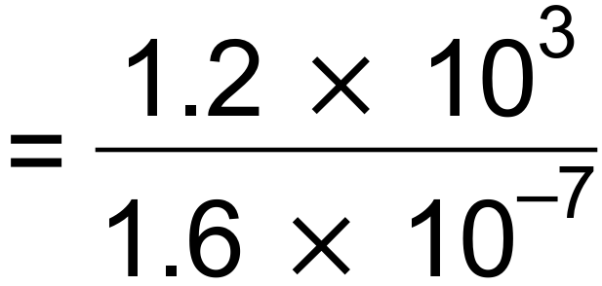
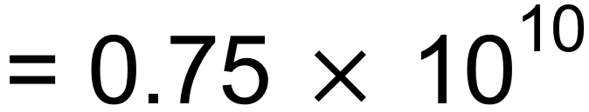
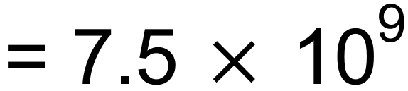
(b) (i) 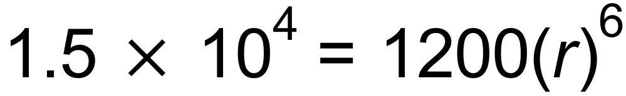
P₀ = 1200
r = 1.5234
(ii) P = 187500
(iii) 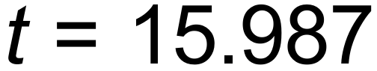
15 hours and 59 minutes. [8]

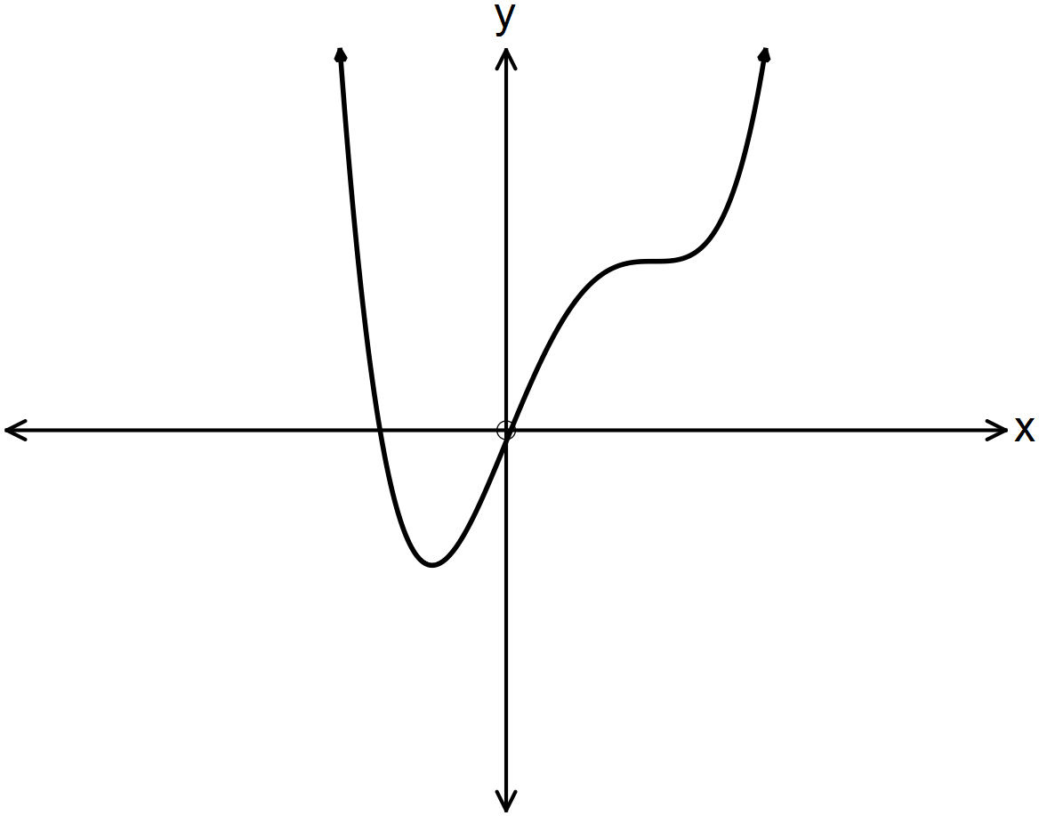18. (a)

A | B | C
(iii) | (ii) | (i)
(b)

[6]

19. (a) (i) n = 13
T₁₃ = 26 + (12)(2)
= 50 seats
(ii) n = 23 Row W
(iii) n = 24
Sum of seats = 1176

(b) 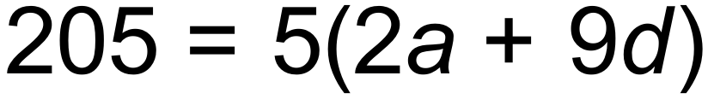
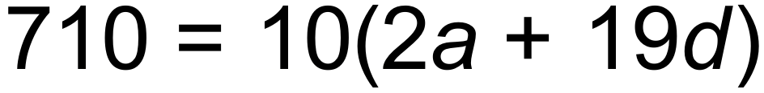
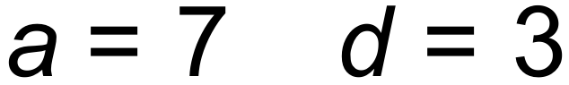
S₃₀ = 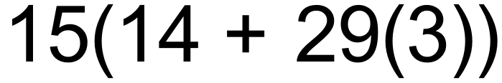
= 1515

(c) 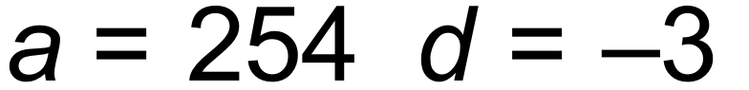 T_{n} = 176
176 = 254 + 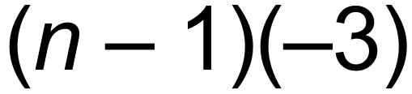
n = 27
S_{n} = 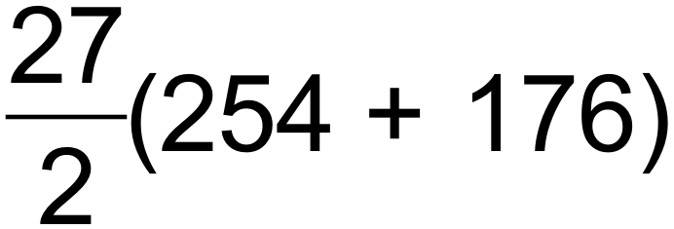
= 5805 [10]

20. (a) 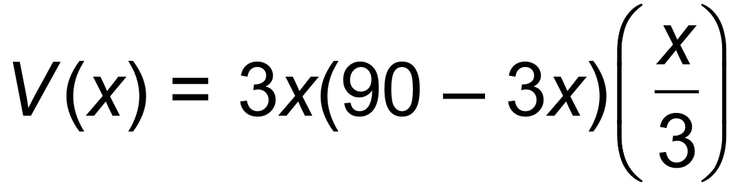
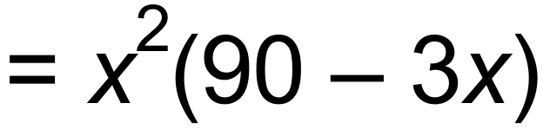
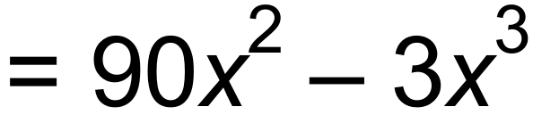
(b) 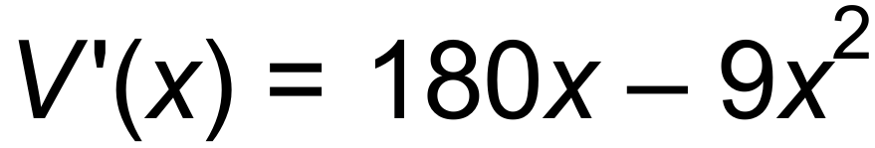
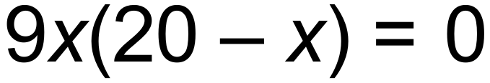
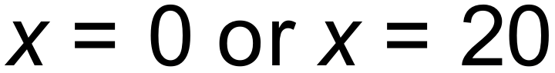
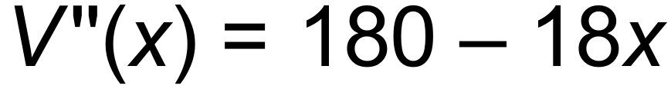
Maximum volume is 12000 m³
When length = 60 m, width = 30 m and depth= 6.67 m [6]

21. (a) (i) A₁ =  A₂ =  A₃ = 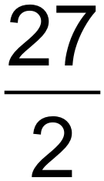
(ii) A_{n+1} = 3 A_{n} A₁ = 
(iii) S₂₅ = 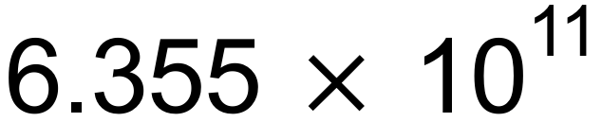

(b) (i) T_{n} = 2 T_{n – 1} T₀ = 6
T₁₂ = 24 576 users
(ii) After 18 months
(Or during the 18th month)
(iii) 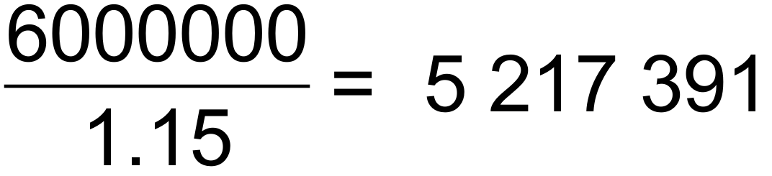 users
During the 20th month
(c) S∞ = 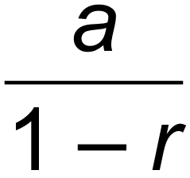
= 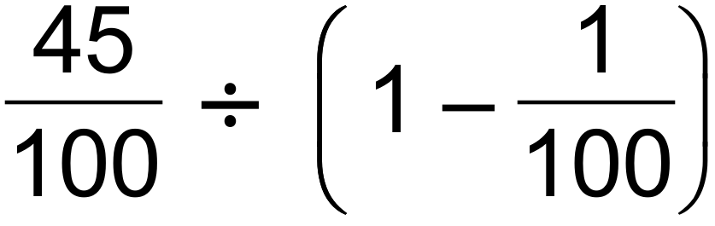
= 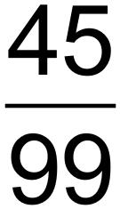
= 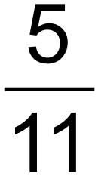 [13]

22. (a) 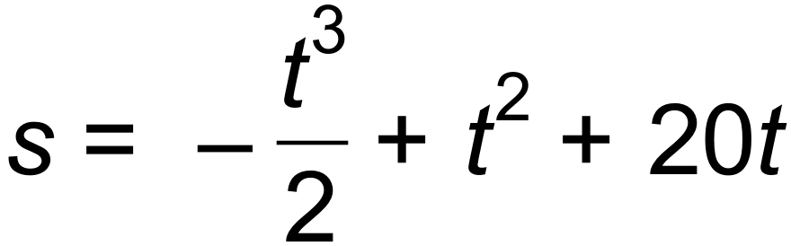. 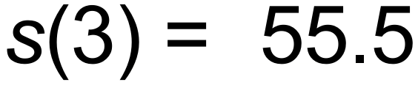 m
(b) 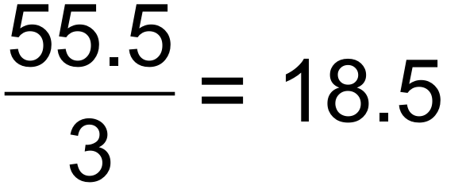m/s
(c) 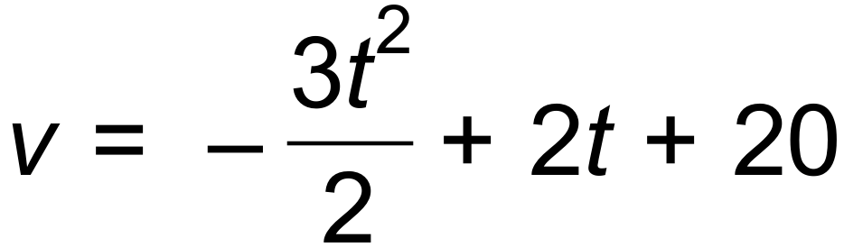
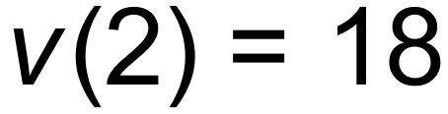 m/s
(d) 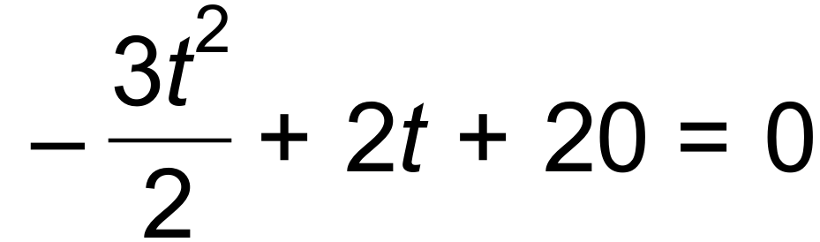
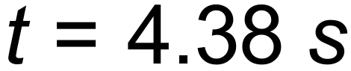
Max displacement: 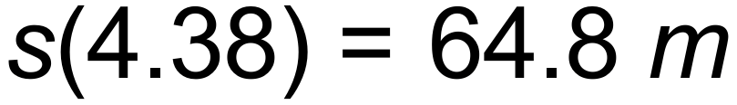
(e) 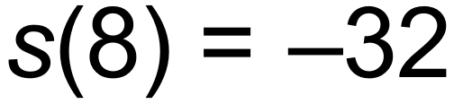
Total distance = 64.8 + 64.8 + 32 = 161.6 m [9]

23. (a) 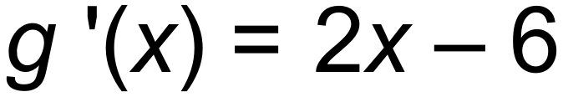
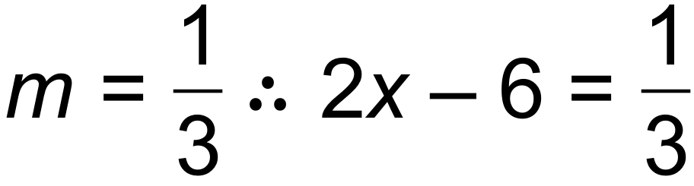
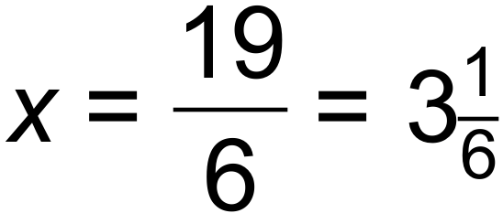
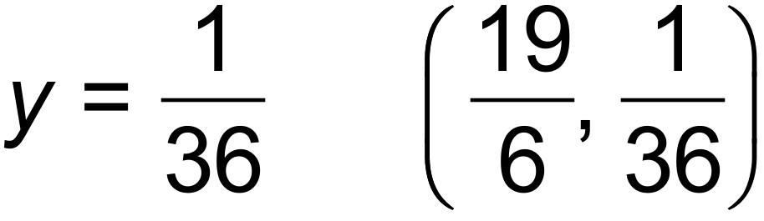
(b) (i) 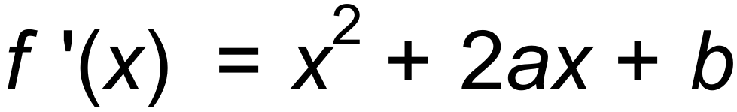
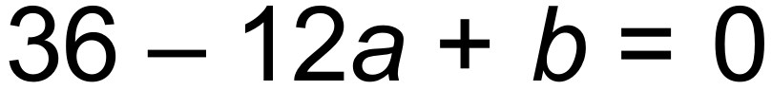
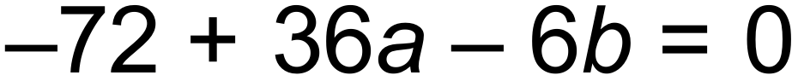
Solving simultaneously 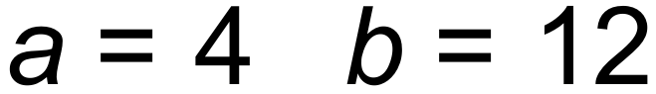
(ii) 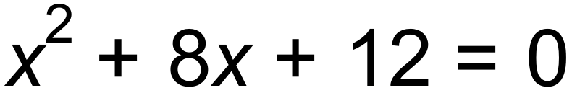
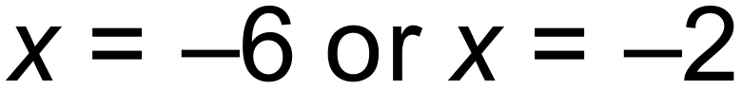
Turning point 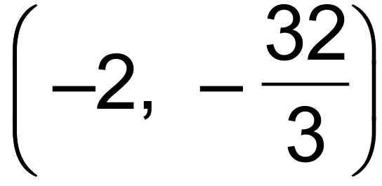
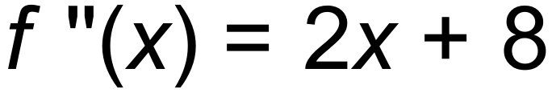 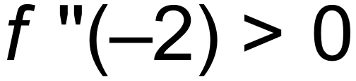 Therefore Local Minimum [9]

End of Questions

